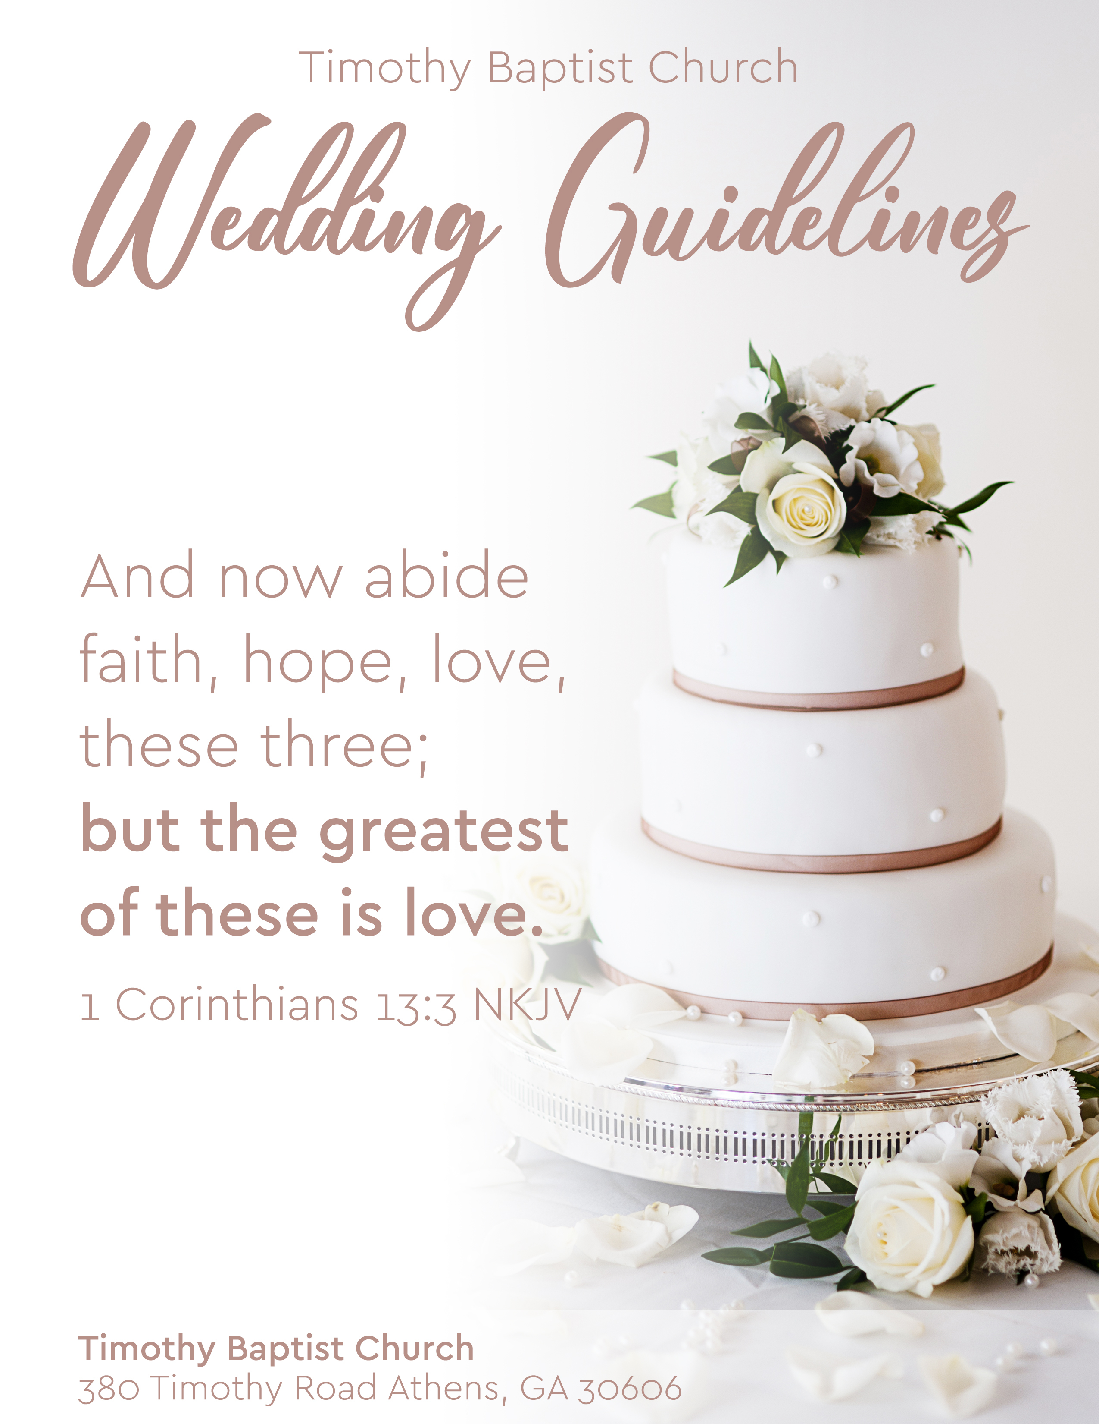



**A Message to the Bride and Groom**

We are blessed that you have chosen to be married at Timothy Baptist Church.

Questions are often asked concerning the guidelines of the church for weddings. The Pastor, Ministers, Staff, and Wedding Directors have put together this pamphlet to help you have a lovely wedding within the context of a Christian worship service. Please read it carefully before you meet with our Minister, Music, and Wedding Director.

The sanctuary and fellowship hall are available for weddings and can be made festive and beautiful while maintaining the atmosphere of a House of Worship.   We believe that a church wedding is a worship service reflecting a joyful, reverent and dignified celebration. By having your wedding in the church, you are making a statement about the value you have for Christian worship, both for yourself and for the new family that begins with your marriage.  Timothy Baptist Church recognizes marriages only between a man and a woman as ordained by God and set forth in scripture.

The Church requires an ordained Minister to perform all weddings.  Should you request to have an outside Minister perform the wedding, he or she must be approved by the Senior Pastor. In addition, the Church requires our Wedding Director to be available to answer questions and to ensure that the guidelines are adhered to.

A Sound/Audio Technician will be present for the rehearsal and wedding to assist with the audio and other technological needs. The Bride and Groom should arrange a conference with their Minister well in advance of the wedding date for pre-marital counseling.  Please obtain the marriage license at least a week in advance and give it to the Minister who will perform your ceremony.

Our Director of Music can assist you in all decisions related to Musicians and music selection.  If you wish a Musician not on our staff to play for your wedding, our Director of Music must approve all Musicians and music selections.

**Responsibility**

It is your responsibility to adhere to the policies and standards stated in this pamphlet, as well as, to ensure that your Florist, Photographer, Videographer, caterer, and any other vendor understand the policies that concern them.

The reserving party will be responsible for supervising the wedding activities and the conduct of those present.  Please remember that this is a Church facility and appropriate conduct of all participants is expected.

Children must be supervised at all times in all areas of the facility.  Running indoors is not permitted to ensure everyone’s safety.

Before any wedding date is guaranteed, the application form must be completed and returned to the church office with the deposit before the wedding date is secure.  A Staff Minister, our Director of Music and the Wedding Director are to be contacted to verify their availability to assist with and/or perform the wedding service. Upon receipt of your application and deposit, the date will be held for fourteen days to allow you to secure a Minister, Director, Organist, Photographer, and Florist. If this information is not provided within this time period, the date will be released and your deposit will be refunded. This must be done before other plans or announcements are made.

The deposit is refundable after the wedding, provided no damage has occurred and all policies are respected and adhered to.  All areas of the church used during the rehearsal, wedding and/or reception will be inspected by the Wedding Director and the custodian.  Any problems which cause the Church added expense will be reported to the Church Office and that expense will be deducted from the deposit.  If the cost of the damage exceeds $200.00, the person reserving the facility will be billed the additional amount.

The Wedding Director’s main responsibility is to supervise the details of the rehearsal and the wedding ceremony and to be the church’s representative.  Should you decide to hire your own personal Wedding Coordinator to assist you with the planning of your wedding, the Wedding Director for Timothy Baptist Church will schedule a preliminary meeting with you and your Wedding Coordinator to review church policies, answer questions, offer suggestions and discuss your wedding details.  A second meeting will be scheduled closer to your wedding date to confirm details and discuss a timeline for the wedding day.  At the rehearsal, the Wedding Director will provide instructions and answer questions for the wedding party. On the wedding day, the Wedding Coordinator will be on the premises to assist the bride, the bridal party and all vendors and the

Wedding Director for Timothy Baptist Church will supervise to ensure that things go according to schedule.

The decision to perform a marriage ceremony is the right and responsibility of the Minister.  If you need one of our Ministers to perform the wedding ceremony, please contact the church office as soon as possible in order to check availability. The Minister who will perform your wedding ceremony must provide pre-marital counseling, discuss and plan your wedding with you. If a minister other than a Minister from Timothy Baptist Church is to be used, please have your Minister contact our Minister no less than one month prior to the wedding.

**Time and Date**

Timothy Baptist Church **members** may reserve the church up to one year in advance of their wedding date.  **Non-members** may reserve the church up to six months in advance of their wedding date.

Rehearsals will be held no earlier than 6:00PM and end no later than 9:00PM.  Exceeding this time frame will result in a $25 per quarter hour deduction from the deposit.

The Church will open three hours before and close one hour after the wedding. The Church Wedding Director will be present to ensure that things go according to schedule and to answer questions you or your bridal party may have during this time.  Any change made in the time of the ceremony or rehearsal should be discussed with the Church Wedding Director and your Wedding Coordinator.

Saturday evening weddings will be scheduled to allow ample time to prepare the church for Sunday morning activities.  Weddings will **not be scheduled** for the following: Holy Week, Palm Sunday weekend, Thanksgiving weekend, Christmas Eve through New Year’s Day, or Sundays.

**Dressing Rooms**

The Nursery and adjoining rooms (located on the first floor) are available to the Bride and her attendants for dressing. The room includes access to an adjoining restroom and a mirror.

The Groom and Groomsmen’s dressing room is located in the Multi-Purpose Room within the main church building.

**Under no circumstances will food or drink be permitted in the Sanctuary or vestibule areas.**

**Smoking and alcohol are NOT PERMITTED on the church premises, including the church parking lots.**

The Bride should have a designated person to remove the bridal party’s possessions, food and drink from the dressing rooms within an hour following the ceremony.  Items left behind will be held for 30 days and then disposed of.  It is the wedding party’s responsibility to contact the church regarding lost items.

**Decorations**

Decorations are to be completed no later than one hour before the wedding service begins. Do not attach anything to painted walls, woodwork, furniture or floors.  Pews may have bows, bouquets, etc. but no nails, tacks, or staples may be used to attach decorations.

Rice, confetti, birdseed, or flower petals are not to be thrown in the Church building or

entrances.  Bubbles are allowed outside only.

**Your Wedding Coordinator should discuss with the Bride and her Florist plans for decorating the sanctuary.**Your Florist is responsible for seeing that all floral arrangements and other decorations are removed immediately after the wedding service.  No nails, tape or screws are to be used for attaching decorations to walls, panels or pews.

Church furnishings will not be moved or removed to accommodate decorations.  However, the pulpit podium/lectern can be moved, along with the drum set, upon request.  All other pulpit and choir stand furnishings are not to be moved.  The piano and organ will not be moved and no decorations will be placed on them.

All decorations must be removed immediately following the wedding and/or reception.  Please make arrangements with your caterer to remove all items the day of the wedding.

**Candles**

Only metal candles (15” or 18” tall) or wax **“dripless”** candles are allowed for use in candelabras.  The Florist should be able to provide metal candles or dripless candles, as the church does not furnish them.  Arrangements should be made by the Florist or the Bride to have the candles taken away after the wedding ceremony.  Any additional candles used must be provided by and are the responsibility of the bride, including unity and memory candles, and must be metal or “dripless.”

Candles are not to be carried down the aisle by members of the wedding party.  In all circumstances, special attention needs to be paid so that no wax drips on the floor or carpet (plastic may need to be placed on the floor).  Should additional labor costs be incurred due to cleaning waxy residue from carpeting or flooring, there will be a deduction from the deposit.

To protect against damage from dripping wax, plastic must be used to protect the carpet if a floor arrangement or candles are used.

**Holidays and Decorations**

When weddings are scheduled during holiday seasons and the church has been decorated, you must incorporate the seasonal decorations into the wedding décor.  Decorations for the holiday seasons in the church may not be moved.  Please contact the Wedding Director with questions.

Remember: Weddings will not be scheduled for Holy Week, Thanksgiving weekend, Christmas Eve through New Year’s Day, or Sundays.

**Photographs and Videos**

Your wedding is a worship service in the Timothy Baptist Church and **no flash pictures are to be taken during the service.** Pictures are to be completed in the Sanctuary 45 minutes prior to the start of the ceremony.  Please remind your photographer and inform your guests of this important policy.

In keeping with a service of worship in Timothy Baptist Church, **the only video camera(s) permitted in the Sanctuary will be placed in the choir stand or in the rear of the church, where it does not impede the flow of traffic or pose a fire hazard.**Please inform your Videographer of this policy.

**Music**

A “Service of Christian Marriage” is a worship service.  It is the responsibility of our Director of Music to oversee all musical portions of the wedding service and to see that all music is appropriate for Christian worship.  The Director of Music should be consulted early in the planning of all weddings in the Church.  The Director of Music fee includes a one-hour consultation with the Bride, a one-hour rehearsal, and the wedding itself.  If additional rehearsals with Soloists, Instrumentalists, (etc.…) are required, additional fees will be negotiated.  If the Director of Music is not available, he/she will provide you with a list of approved Musicians. Their involvement and fee would be negotiated by the Bride.  If you would like to bring in an outside Musician, they will simply need to contact the Director of Music in advance in order to be approved. If you require other instrumentalists, soloists, etc.… the Director of Music can assist you by providing names and contact information.

In the event that an outside organist or soloist is used, our Director of Music must approve the music.

**Reception & Rehearsal Dinner Guidelines**

* **Fellowship Hall Usage**: The Fellowship Hall may be available for receptions and rehearsal dinners. Please confirm availability and make necessary arrangements through the Church Office.
* **Catering Requirements**: A state licensed catering service is required for all receptions and rehearsal dinners held on church premises. The selected caterer is responsible for:
  + Providing all necessary equipment, including china, silverware, glassware, and serving utensils.
  + Utilizing the Fellowship Hall, kitchen space, and ice machine exclusively for catering and food service-related activities
  + Thoroughly cleaning the Fellowship Hall and kitchen areas after the event.
  + **Please note:** The use of stoves and refrigerators is not permitted.
  + **Important Note:** Upon arrival, the caterer will be required to sign a written agreement with our Food Service Director, outlining responsibilities and expectations for facility use.
* **Church Equipment**: The church offers tables and chairs for use during events. To utilize these, arrangements must be made in advance with the Church Office.
* **Prohibited Items and Activities**:
  + **Alcohol**: Alcoholic beverages are strictly prohibited on all church property, including buildings and parking areas.
  + **Throwing of Materials**: The use of rice, confetti, birdseed, flower petals, or similar materials is not permitted inside the church or at any entrances.
  + **Bubbles**: Bubbles may be used **outside** the church building only.

These guidelines are established to maintain the sanctity and cleanliness of our facilities. We appreciate your cooperation in adhering to these policies.

**Please Remember…**

* Upon receipt of your application and deposit, the date will be held for fourteen days to allow you to secure a Minister, Director, Musician, Photographer, and Florist.
* The balance of fees for the wedding is due in the Church Office four weeks prior to the wedding.
* **Smoking and alcohol are not permitted on the Church premises, including the church parking lots.**
* Nails, tape and screws are not to be used to attach decorations to walls, panels or pews.
* Decorations for the holiday seasons in the church will remain in the sanctuary and will be incorporated into the wedding decorations.
* Any changes from the wedding application must be made with the Church Wedding Director.

**One Last Note**

We are blessed that you have chosen to be married at Timothy Baptist Church.  We wish you joy and fulfillment in your new life.

Timothy Baptist Church

380 Timothy Road

Athens, Georgia 30606

(706) 549-1435

Fax (706) 546-9942

www.timothybaptistchurch.org

A wedding application is available on our website.

**Wedding Director**

Juanita Page - 706-202-6799 – juanitapage77@gmail.com